|  |
| --- |
| 3MINI PROJECT REPORT **ON**  **Computer Sales System**  as a part of  ***Project Based Learning***  **Submitted by**  **Tejas R Hagavane**  **Aniket T Chaudhari**  **Tejas D Jadhav**  **Aditya K Dayal**  **Guided by**  **Prof. J. R. Sohale**  Master of Computer Applications  (Under Faculty of Engineering)  Department of MCA  K. K. Wagh Institute of Engineering Education & Research  Hirabai Haridas Vidyanagari, Amrutdham, Panchavati,  Nashik – 422 003 |

|  |
| --- |
| **K. K. Wagh Institute of engineering education & research**  **NasHik - 422003**  ***CERTIFICATE***  This is to certify that  **Tejas R Hagavane**  **Aniket T Chaudhari**  **Tejas D Jadhav**  **Aditya K Dayal**  has successfully completed the Mini Project on  Computer Sales System  as a part of  ***Project Based Learning***  during academic year 2021 – 22  **Prof. J. R. Sohale Prof. V. C. Bagal Dr. K. N. Nandurkar**  Project Guide I/c Head, Principal  Dept. of MCA |

**Computer Sales System**

**A Project Report**

Submitted in partial fulfillment of the

Requirement for award of the degree of





**DECLARATION**

I hereby declare that the project entitled “**Computer Sales System”** isdone at KK Wagh has not in been any case duplicated to submit to any other university for the award of any degree. To the best of my knowledge other than us, no one has submitted to any other university.

The project is done in partial fulfillment of the requirements for the award of degree of MCAto be submitted as final semester project as part of our curriculum.

**Name and Signature of the Students** 

**ABSTRACT**

Sales managers should not be recruiters and cheerleaders but business managers of territories, districts, and regions, with all the problems of scarce resources, government regulation, and shrinking profits. This article illustrates how microcomputers can help sales managers at all levels deal with the pressure and overcome the problems. These computers can help them plan sales strategies, develop and evaluate representatives, and estimate the outcomes of different strategies.

**TABLE OF CONTENT**

**DECLARATION**

**ABSTRACT**

**CHAPTER – 1: INTRODUCTION**

1.1 Problem Definition

1.2 Scope

1.3 Applicability

1.4 Organization of Report

1.5 Feasibility Study

**CHAPTER – 2: SURVEY OF TECHNOLOGIES**

2.1 Existing System

2.2 Proposed system 

2.3 Technology Survey

**CHAPTER – 3: REQUIREMENTS & ANALYSIS **

3.1 Problem Statement

3.2 Requirement Analysis

3.3 Scheduling and Planning

3.4 Software and Hardware Requirement

**CHAPTER – 4: MODELING**

* 1. Entity Relationship Diagram [ERD]
  2. Data Flow Diagram [DFD]
* Zero level diagram
* First level diagram
* Second level diagram

4.3 Uml diagrams

* Use case diagram

4.4 Class diagram

4.5 Sequence diagram

4.6 Activity diagram

4.7Component diagram

4.8Test Case Design

**CHAPTER – 5: IMPLEMENTATION & TESTING**

5.1 Testing Approach

5.2 Unit Testing (Test case and Test Results)

5.3 Integration System (Test cases and Test Results)

5.4 Data Dictionary

5.5 RESULTS AND DISCUSSION

**CONCLUSION**

**REFERENCES**

**ACKNOWLEDGEMENT**

**Chapter 1**

**Introduction**

This chapter gives an overview about the background, Objectives, Purpose, Scope and Applicability, Achievements and Organization of Report of the system.

**Problem Definition :**

The problems that occurred before having computerized system includes:

1. **File Lost** :-When computerized system was not implemented file was always lost because of human environment. Sometimes due to human error, there may be a loss of records.
2. **File Damaged** :-When a computerized system was not their file was always lost due to some accident like spilling of water by some member on file accidentally. Besides some natural disaster like floods or fires may also damage the files
3. **Difficult to search Records** :-When there was no computerized system, there was always a difficulty in searching of records if the records are large in number.
4. **Space Consuming** :-After the number of records becomes large, the space for physical storage of file and records also increases if no computerized system is implemented.
5. **Cost Consuming** :-As there is, no computerized system to add each record paper will be needed which will increase the cost for the management of shop.

**Scope** :

Our Computer Sales Management System make work done at the faster way the software is User-Friendly and Attractive. Owner of the Association can edit Products details, which can be viewed by the administrator.

* Drawbacks in the system:

1. Time consuming.
2. Possibility of human error.
3. Customers has to wait until the shopkeeper finishes with the other customers if there is rush.
4. Waste of time.
5. Increases paper work.
6. Shopkeeper or salesman have to remember details of Product such as company, price etc.
7. Problem in handling the stock.

**APPLICABILITY**:

* This system is desktop oriented so it does not required any internet connection. It will be easy to use and low cost system.

**ORGANISATION OF REPORT :**

Throughout the remainder of this report, I describe the process I used to create the application, from research to development. Each chapter focuses on a specific aspect of the process.

Chapter 2 discusses the survey of technologies and applications and presents a high-level overview of ideas related to proposed system.

Chapter 3 requirements and analysis and the process involved in creating the different user interface for user as well as analysis of proposed system.

Chapter 4 describes the system design and how system will going to work in future with algorithm and detailed explanation about proposed system.

**Feasibility Study:**

* Whatever we think need not be feasible. It is wise to think about the feasibility of any problem we undertake. Feasibility is the study of impact, which happens in the organization by the development of a system. The impact can be either positive or negative. When the positives nominate the negatives, then the system is considered feasible. Here the feasibility study can be performed in two ways such as technical feasibility and Economical Feasibility

**A) Technical Feasibility: -** Technical Feasibility: We can strongly say that it is technically feasible, since there will not be much difficulty in getting required resources for the development and maintaining the system as well. All the resources needed for the development of the software as well as the maintenance of the same is available in the organization here we are utilizing the resources which are available already.

**B) Economic Feasibility: -** Economic Feasibility: Development of this application is highly economically feasible. The organization needed not spend much m one for the development of the system already available. The only thing is to be done is making an environment for the development with an effective supervision. If we are doing so, we can attain the maximum usability of the corresponding resources. Even after the development, the organization will not condition to invest more in the organization. Therefore, the system is economically feasible.

**C) Operational Feasibility: -** Operational Feasibility is a measure of how well a proposed system solves the problems, and takes advantage of the opportunities identified during scope definition and how it satisfies the requirements analysis phase of the system development. Operational feasibility reviews the willingness of the organization to support the proposed system. This is probably the most difficult of the feasibility to gauge.th operational feasibility is the one that will be used effectively after it has been developed

**Chapter 2**

**SURVEY OF TECHNOLOGIES**

**Existing System**

* Existing System has no security measure against logging checks are made for authorizing users.
* Existing System has lack of interactivity
* Customer and Product managed.
* Stock availability for customer requirement are solved problem

**Proposed System**

Proposed system is an automated Computer sale Management System. Through our software user can add Customers, add products, search customers, search products, update information, edit information, sales and service products in quick time. Our proposed system has the following advantages. User-friendly interface

1. Fast access to database
2. Less error
3. More Storage Capacity
4. Feel Environment
5. Quick transaction

**Technology survey**

We are using 6th generation Intel core i3 processor, leading the park is the Intel core i3-310 processor.

Architected for performance, this processor packs 4 high-performing core with core base frequency of 3.60Hz and 8MB of cache memory.

Ram 4 GB is used as it will provide fast reading and writing capabilities and will in turn support in processing.

The Operating system which is used for our project is Windows 10 because in this operating system is stable and supports more features and is more user friendly.

The Operating system which is used for our project is Windows 10 because in this operating system is stable and supports more features and is more user friendly.

* **Front End NetBeans IDE 8.0.2**

“NetBeans IDE 8.0.2” is mainly used for application programming for Microsoft Windows. It provides GUI, for building the application the application system.

The NetBeans integrated development environment (IDE) delivers. The NetBeans IDE can boost your productivity when you're working with Java SE, Java EE, or Java ME technology as well as PHP, Groovy, JavaScript, and C/C++. Visual tools that generate skeleton code are also available, letting you create a basic application without writing a single line of code.

* **Back End MySQL Server 5.0**

“MySQL Server 5.0” is used in this project as back end. Microsoft Access provides various facilities like creating database, modifying database, editing database.

The Microsoft Access has been used here for purpose of creating necessary database for relevant project.

**Chapter 3**

**Problem statement** 

* This system will work on only NetBeans IDE 8.0.2 Application .
* A lot of time is consumed in manually setting the reminders.
* They don’t facilitate storing the original prescription.

So as I mentioned in above points we have to take note of all problem and we have to try to avoid all above problems.

**Requirement Analysis**

To study any system the analyst needs to collect facts and all relevant information. The facts when expressed in quantitative form termed as data. The success of any project is depended upon the accuracy of available data. Accurate information can be collected with the help of certain methods/techniques. We used four fact finding methods and technique in our system analysis.

* Interview
* Questionnaire
* Record review
* Observation
* **Interview:-**We used this technique frequently in the system analysis after questionnaires. The interviews were unstructured. We choose some people in the organization who were either decision maker or operator or uses some activity related with the project. As we interviewed them many helped us to understand all stages involved.
* **Questionnaire:-** We used this technique in the initial and final phases of our project. In the initial phase we prepared some questionnaire to get some basic information about the current system. Then we used the questionnaire to get some numerical data that was required or missing after all the observation.
* **Record view:-** The information related to the system is published in the source like newspaper, magazines, journals, documents etc. This record review helps the analyst to get valuable information about the system and the organization.

* **Observation:-** While finding the facts we keenly observed all the activities and transaction usage of files and document. Observation helped us in finding out the actual way functioning apart from the ideal or desired.

**Scheduling and Planning**

**PROJECT PLAN**

Project planning defines the project activities and end products that will be performed and describes how the activities will be accomplished. The purpose of the project planning is to define each major task, estimate the time and resources required, and provide a framework for management review and control. The project planning activities and goals include defining:

* The specific work to be performed and goals that define and blind the project.
* Estimates to be documented for planning, tracking, and controlling the project.
* Commitments that are planned, documented, and agreed to by affected groups.
* Project alternatives, assumptions and constraints.

**Project Plan Table**

|  |  |
| --- | --- |
| **Month** | **Activity** |
| April | Feasibility Study And Analysis |
| May | Requirement Gathering |
| June | Implementation |
| July | Testing And Documentation |

**Gantt Chart Of Computer Sales System.**

**Hardware requirements**

1. Processor: Intel Pentium or more.
2. Standard Color Monitor
3. Standard Keyboard and Mouse
4. Inkjet Printer
5. Ram ddr4-8gb

**Software Requirements**

1. Operating System Server: Windows 7/8/10.
2. Database Server: MYSQL Server 5.0.
3. Tools: Net Beans 8.0.2. (IDE)

**Chapter 4**

**Modeling**

**Entity Relationship Diagram [ERD]**

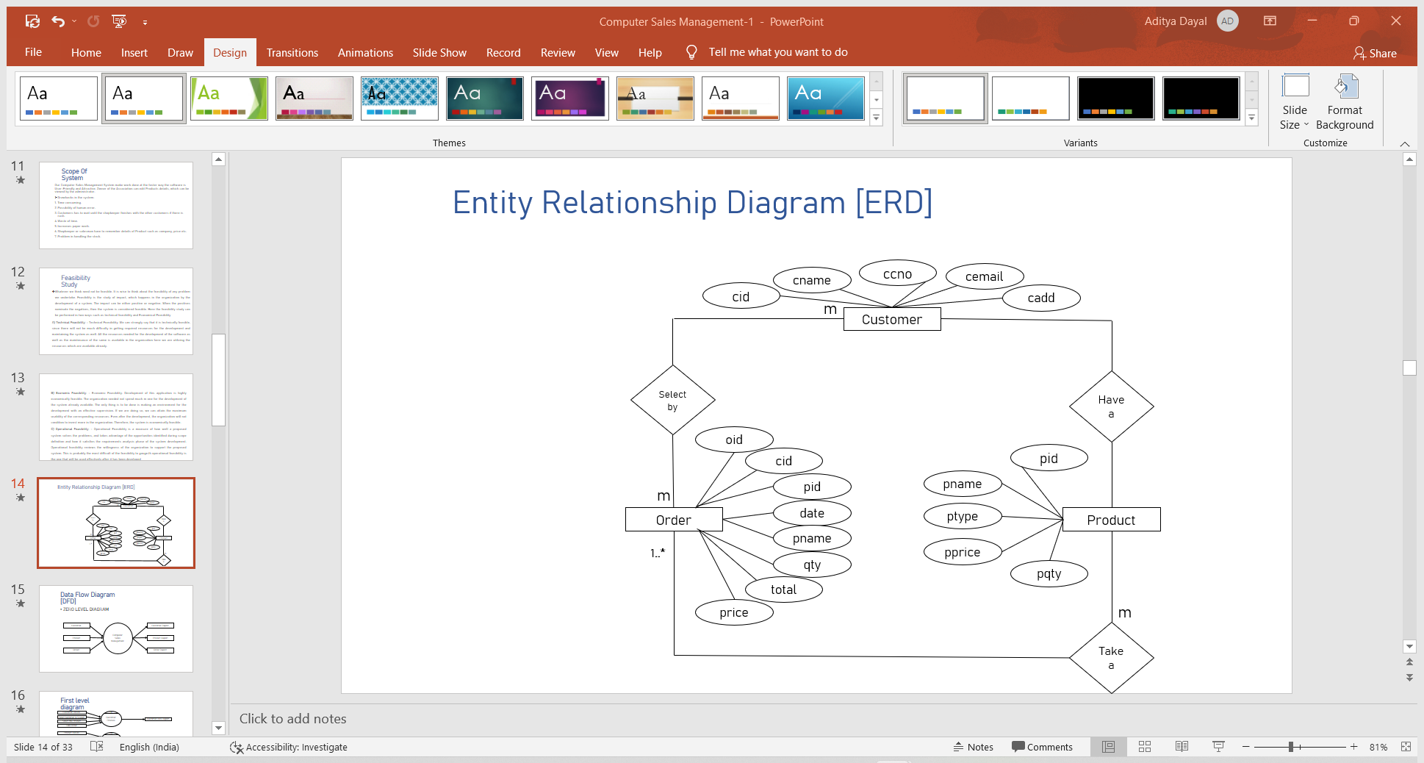

**Data Flow Diagram [DFD]**

* **ZERO LEVEL DIAGRAM**

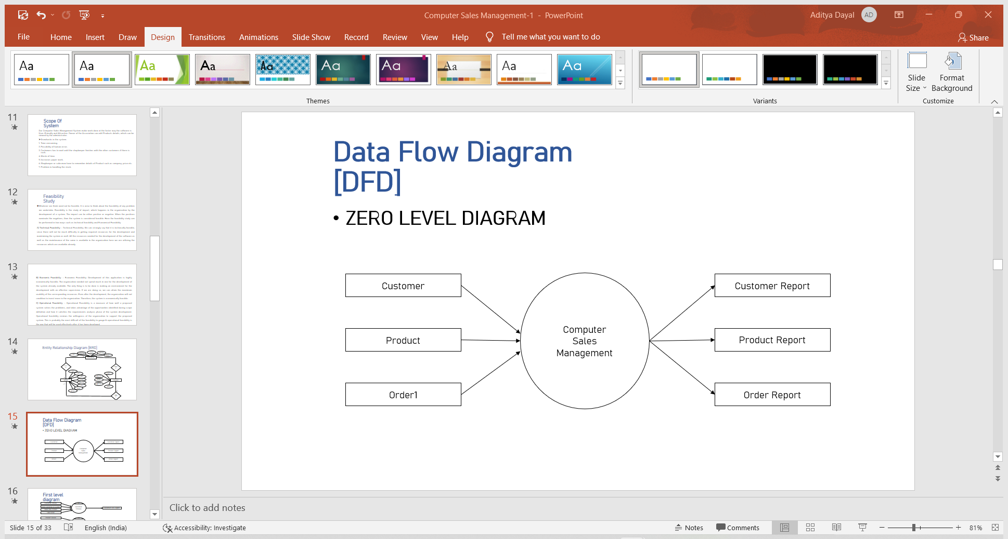

* **FIRST LEVEL DIAGRAM**

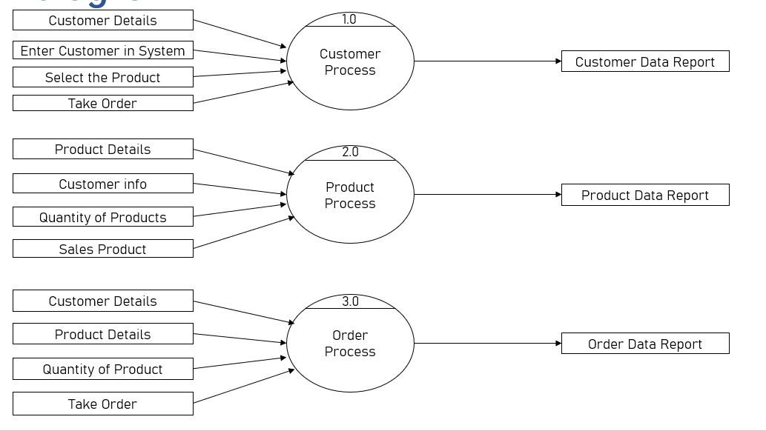

* **SECOND LEVEL DIAGRAM**

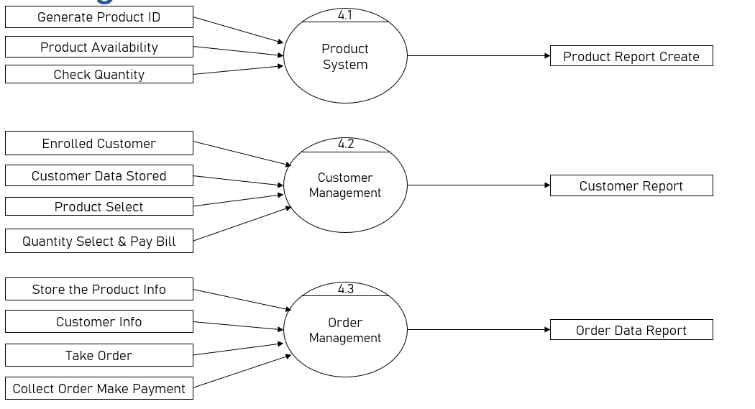

**Uml diagrams**

The Unified Modeling Language(UML) is a general-purpose, developmental, modelling language in the field of software engineering that is intended to provide a standard way to visualize the design of a system. This helps to visualize the system’s architecture in the form a diagram that will represent the individual components of a system, activities and the interaction between the components.

* **USE CASE DIAGRAM**

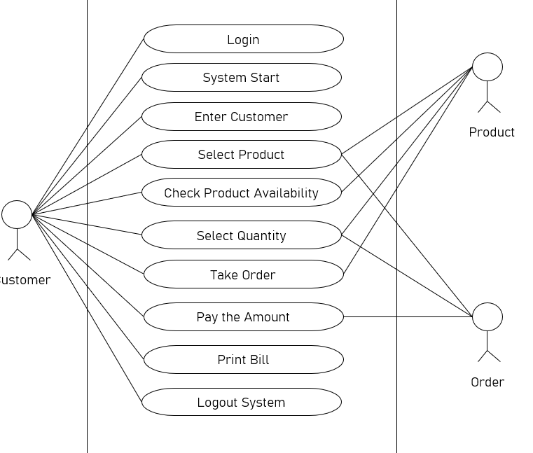

**Class diagram**

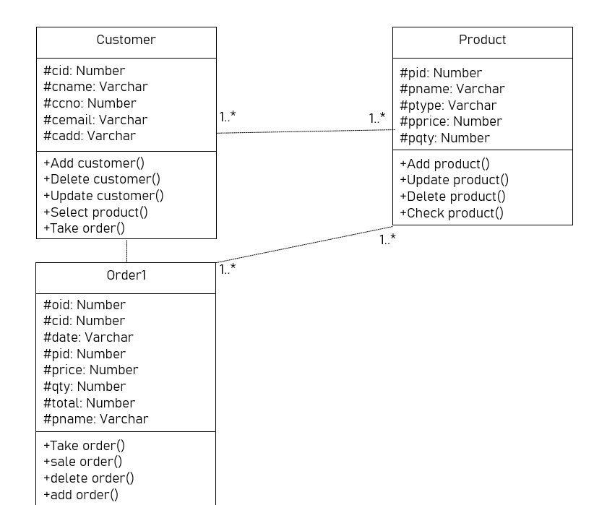

**Sequence diagram**

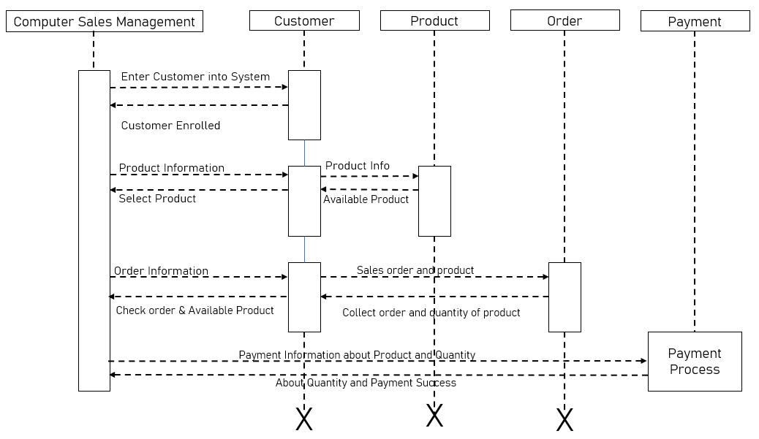

**Activity diagram**

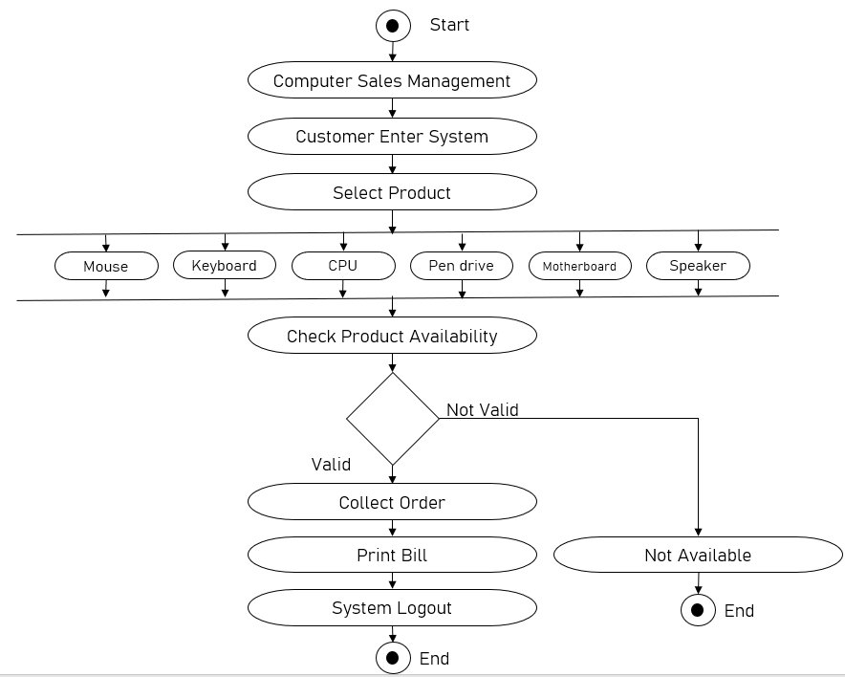

**Component diagram**

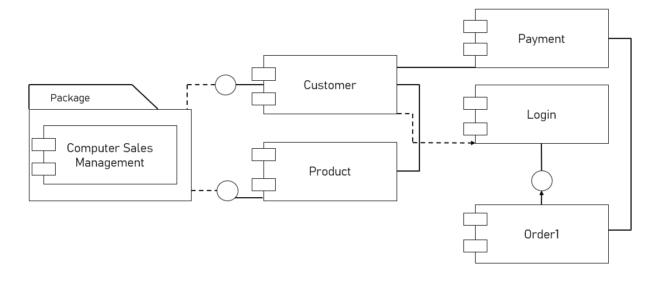

**Test case design**

⮚ **Unit Testing**

Each module is considered independently. It focuses on each unit of software as implemented in the source code in it box testing

⮚ **Integration Testing**

Integration testing aims at constructing the program structure while at the same constructing test to uncover errors associated with interfacing the modules. Modules are integrated by using the top down approach.

⮚ **Validation Testing**

Validation testing was performed to ensure that all the functional Requirements are met.

⮚ **System Testing**  

It is executing program to check logical changes made in it with intention of finding errors a system is testing for online response volume of transection recovery from failure etc. 

System testing is done to ensure their system satisfies all the user requirements.

Acceptance Test a final procedural review to demonstrate a system and secure user approval before a system become operational.

**Chapter 5**

**Implementation and Testing**

**Testing Approach**

Testing is done to evaluate the application based on the requirements obtained from the user and system specifications. Testing should be done in a modular level in the software code. It is always suggested to test the software to check if it has met the business and technical requirements at an early stage. If a bug occurs at the end product, it becomes difficult and expensive to fix it.

The main targets for testing are to look for errors made by the developer in the code, difference between the expected output and obtained output in the software, to look for any bugs that cause the system to fail and to look for failures in the system that occur due to faults in the system. Software testing consists of validation and verification. Validation is the process of checking to see if all the user requirements are satisfied in the system. It makes sure that the end product is obtained in a way that satisfies the user requirements

**Unit Testing (Test case and Test Results)**

Unit testing is a technique in which individual components of the software are tested to check for any errors in the system. It is the smallest testable part of the system. In this, each test case is different

33from the rest and will test to see that individual parts of the program are correct the yare created by programmers during the development process to test and see if the code meets its design and specification

**Integration System (Test cases and Test Results)**

In integration testing, individual units are combined and tested as a group together. This is done after the unit testing. This is done to check that the application works correctly even after the integration of different units together. It is done to bring out the faults between the integrated units when they interact with each other. This testing done by the developers or independent testers.

**Data Dictionary**

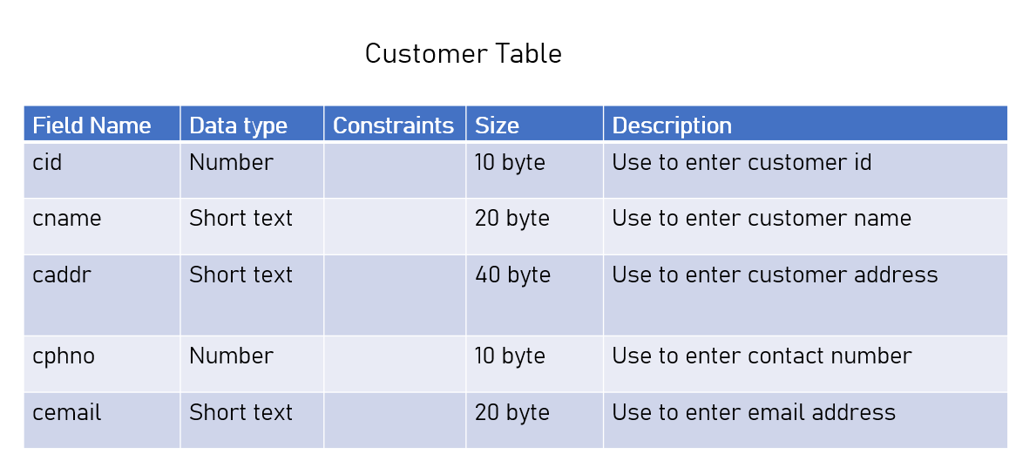

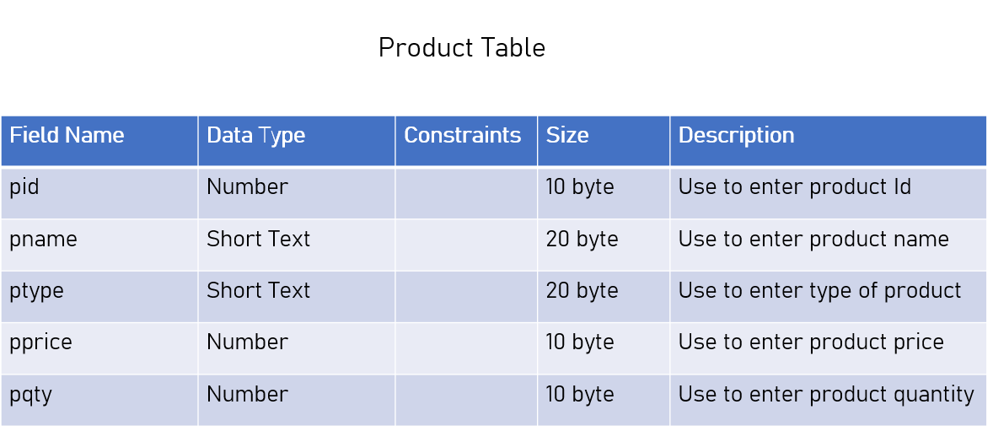

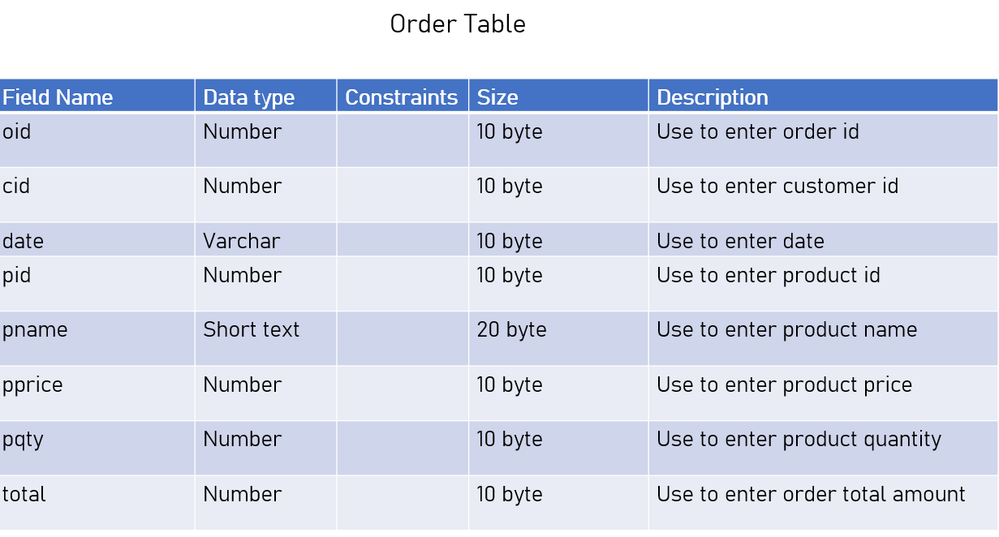

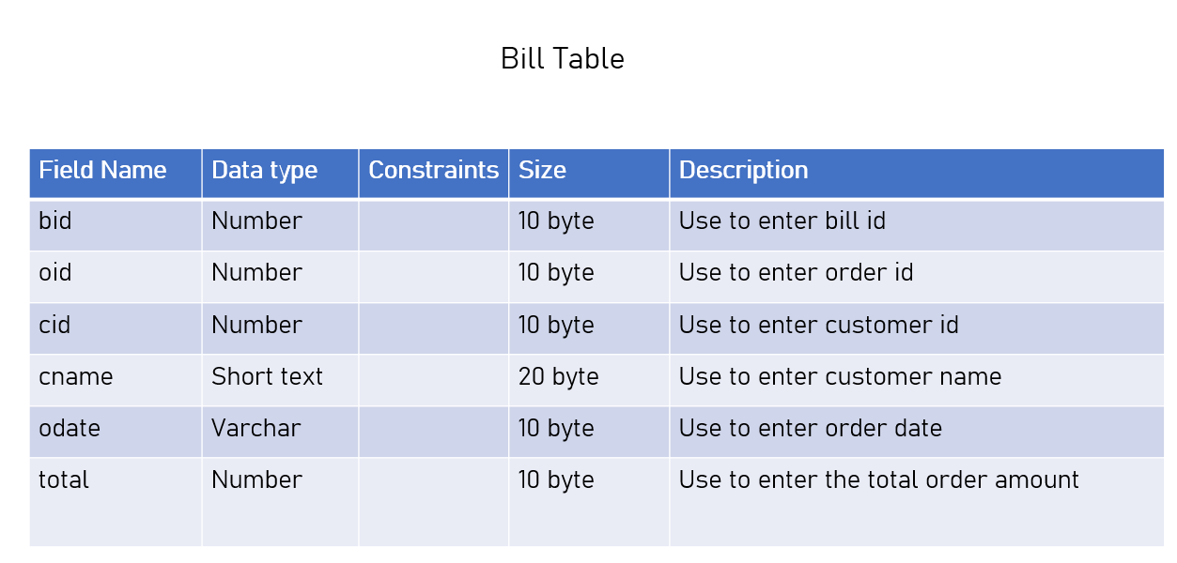

**RESULTS AND DISCUSSION :**

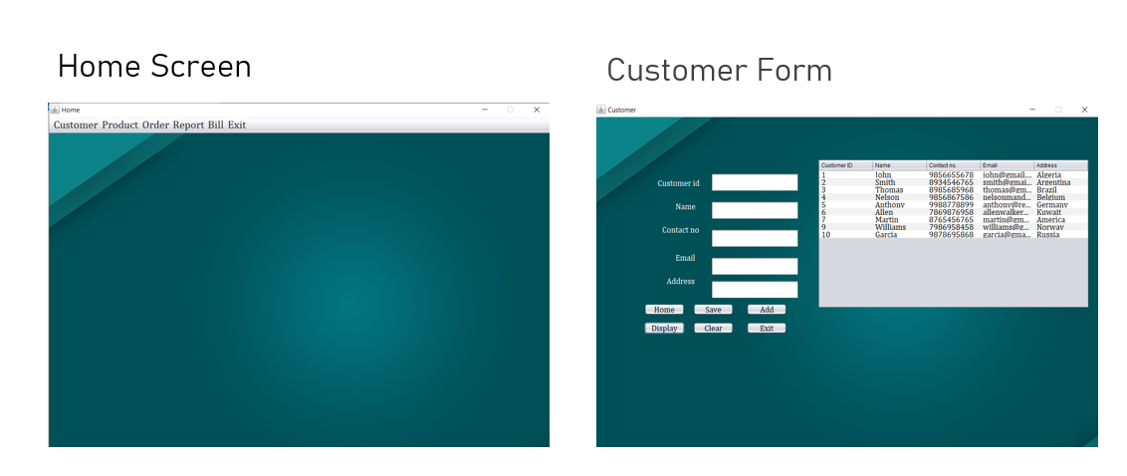

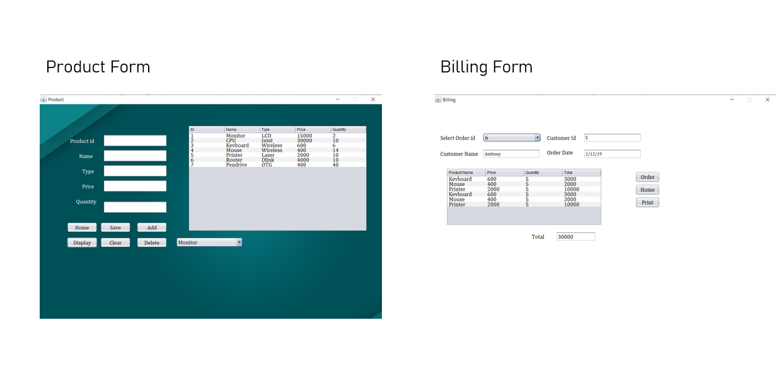

**Order Form**

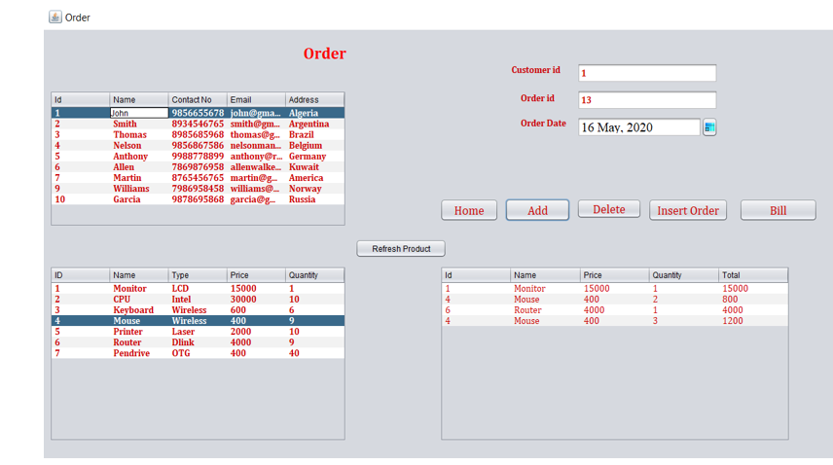

**Order Report**

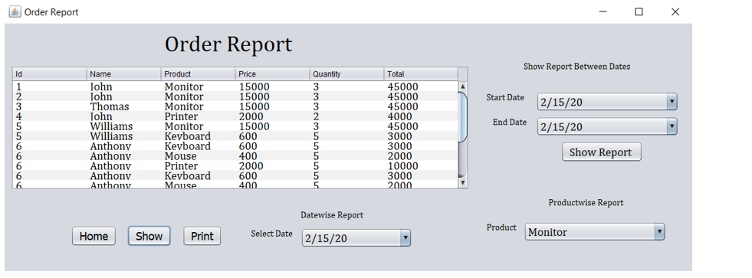

**Conclusion**

Our project Computer sales System has succeeded in managing the details and the list of various types of products in an easy way without taking much time.

**Bibliography**

The material to develop the project on has been taken from following:

* Internet
* YouTube and tutorials
* Friends and teachers
* Vision publication book java and advanced java
* Books: Software Engineering
* www.javapoint.com

**ACKNOWLEDGEMENT**

It gives me a great sense of pleasure to present the report of the Project “**Computer Sales System**” was undertaken during MCA First Year. We would like to thank our Project Guide **Prof. J.R.Sohale** for her full support, encouragement, suggestions and assistance from an early stage during the development of the project. It was a privilege to work under them. We specially acknowledge **Prof. Vijay Dhawale** for his advice, supervision, and the vital contribution as and when required during the completion of our project. And we would not like to miss the opportunity to thank all the members of the department’s intelligence for their kind assistance and co-operation during the whole project .